Assignment 2
Lab: Python Parallel Programming
PRATIK ABHANG | 260740150018
AKANKSHA JADHAO | 260740150004

Exercise 1 — RLock & Recursive Folder Scan
Uses threading.RLock so the same thread can acquire the lock again during recursive calls.
Code:
import threading
class FolderScanner:
def __init__(self):
self.files_scanned = 0
self.lock = threading.RLock()
self.folder = {
"files": ["a.txt", "b.txt"],
"subfolders": {
"sub1": {
"files": ["c.txt", "d.txt"],
"subfolders": {
"sub2": {
"files": ["e.txt"],
"subfolders": {}
}
}
}
}
}
def scan_directory(self, folder):
with self.lock:
for file_name in folder["files"]:
self.files_scanned += 1
print("Scanned:", file_name)
for subfolder in folder["subfolders"].values():
self.scan_directory(subfolder)
if __name__ == "__main__":
scanner = FolderScanner()
thread = threading.Thread(
target=scanner.scan_directory,
args=(scanner.folder,)
)
thread.start()
thread.join()
print("Total files scanned:", scanner.files_scanned)
assert scanner.files_scanned == 5
print("Test passed!")
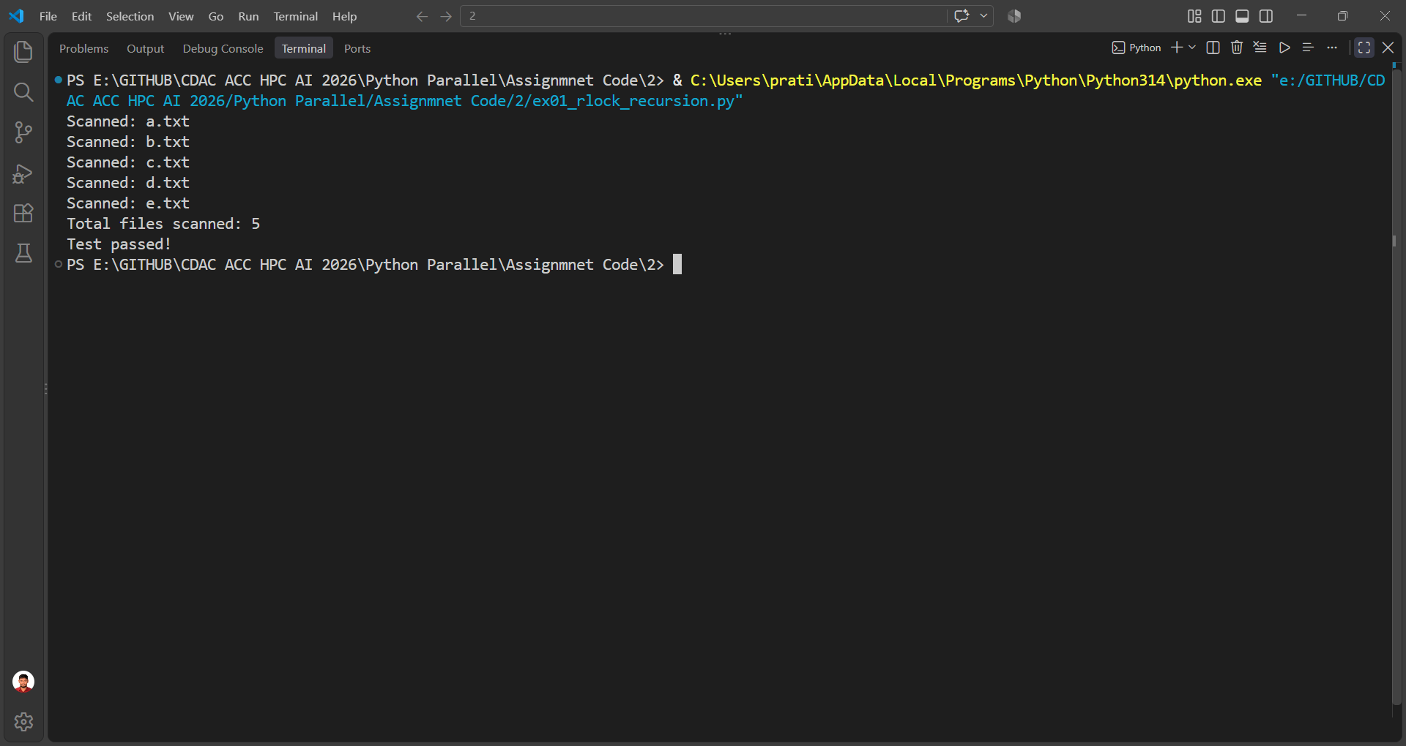

Exercise 2 — Semaphore Connection Pool
Uses Semaphore(3) so at most three workers can use the simulated database at the same time.
Code:
import threading
import time
import random
semaphore = threading.Semaphore(3)
active_connections = 0
lock = threading.Lock()
def worker(worker_id):
global active_connections
with semaphore:
with lock:
active_connections += 1
active = active_connections
print(f"[Worker {worker_id}] Connected to Database "
f"(active slots: {active})")
time.sleep(random.uniform(0.3, 0.8))
print(f"[Worker {worker_id}] Finished query, releasing connection")
with lock:
active_connections -= 1
if __name__ == "__main__":
threads = []
for i in range(1, 11):
thread = threading.Thread(target=worker, args=(i,))
threads.append(thread)
thread.start()
for thread in threads:
thread.join()
print("All workers finished.")
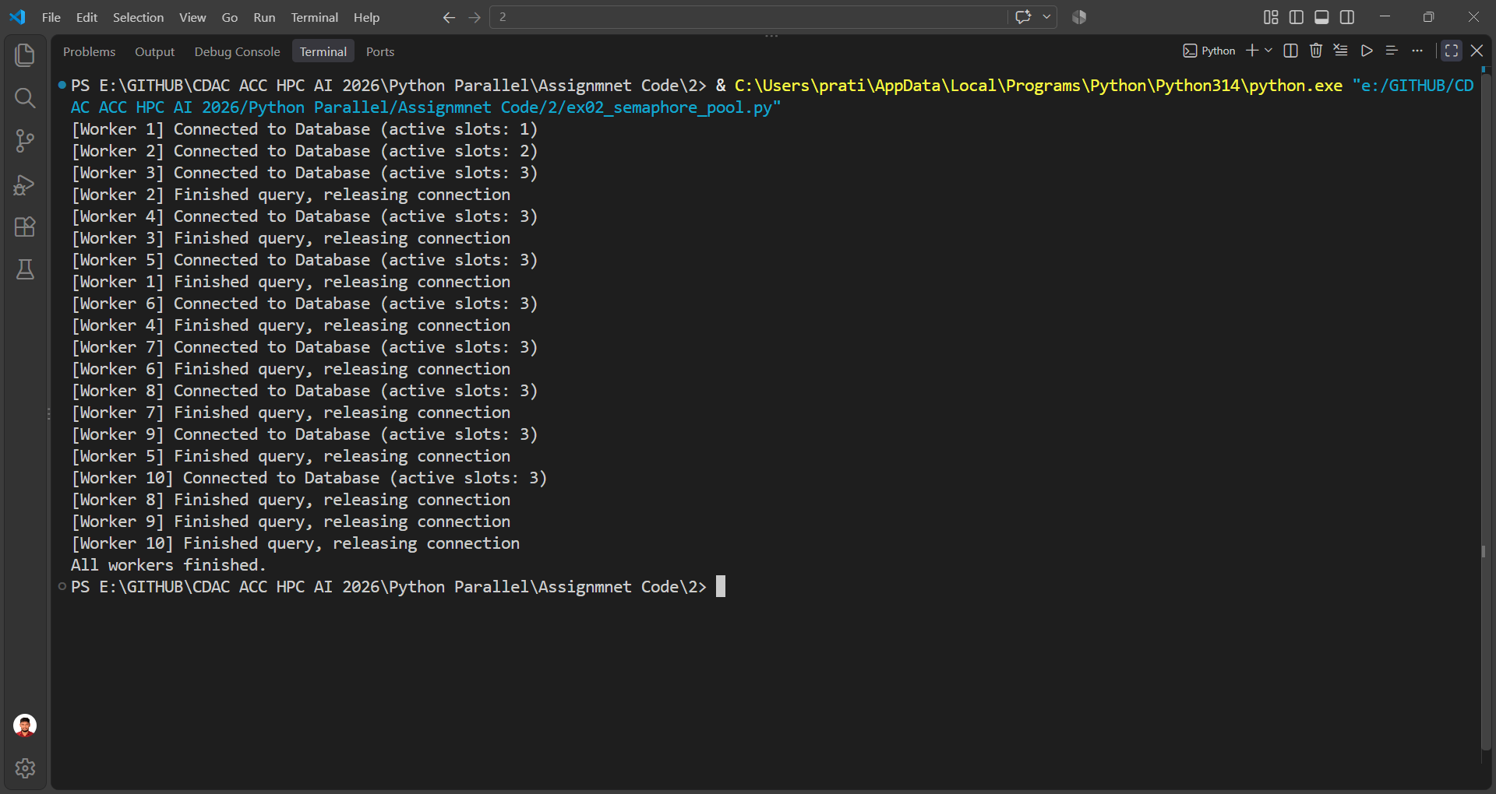

Exercise 3 — Barrier Phased Computation
Four threads complete Phase 1, wait at the barrier, and then calculate their percentage in Phase 2.
Code:
import threading
import random
data = [0, 0, 0, 0]
barrier = threading.Barrier(4)
def worker(i):
try:
# Phase 1
data[i] = random.randint(10, 100)
print(f"[Thread {i}] Phase 1 complete, waiting at barrier...")
barrier.wait()
# Phase 2
total = sum(data)
share = (data[i] / total) * 100
print(f"[Thread {i}] Share of total: {share:.2f}%")
except threading.BrokenBarrierError:
print(f"[Thread {i}] Barrier was broken.")
if __name__ == "__main__":
threads = []
for i in range(4):
thread = threading.Thread(target=worker, args=(i,))
threads.append(thread)
thread.start()
for thread in threads:
thread.join()
print("Data:", data)
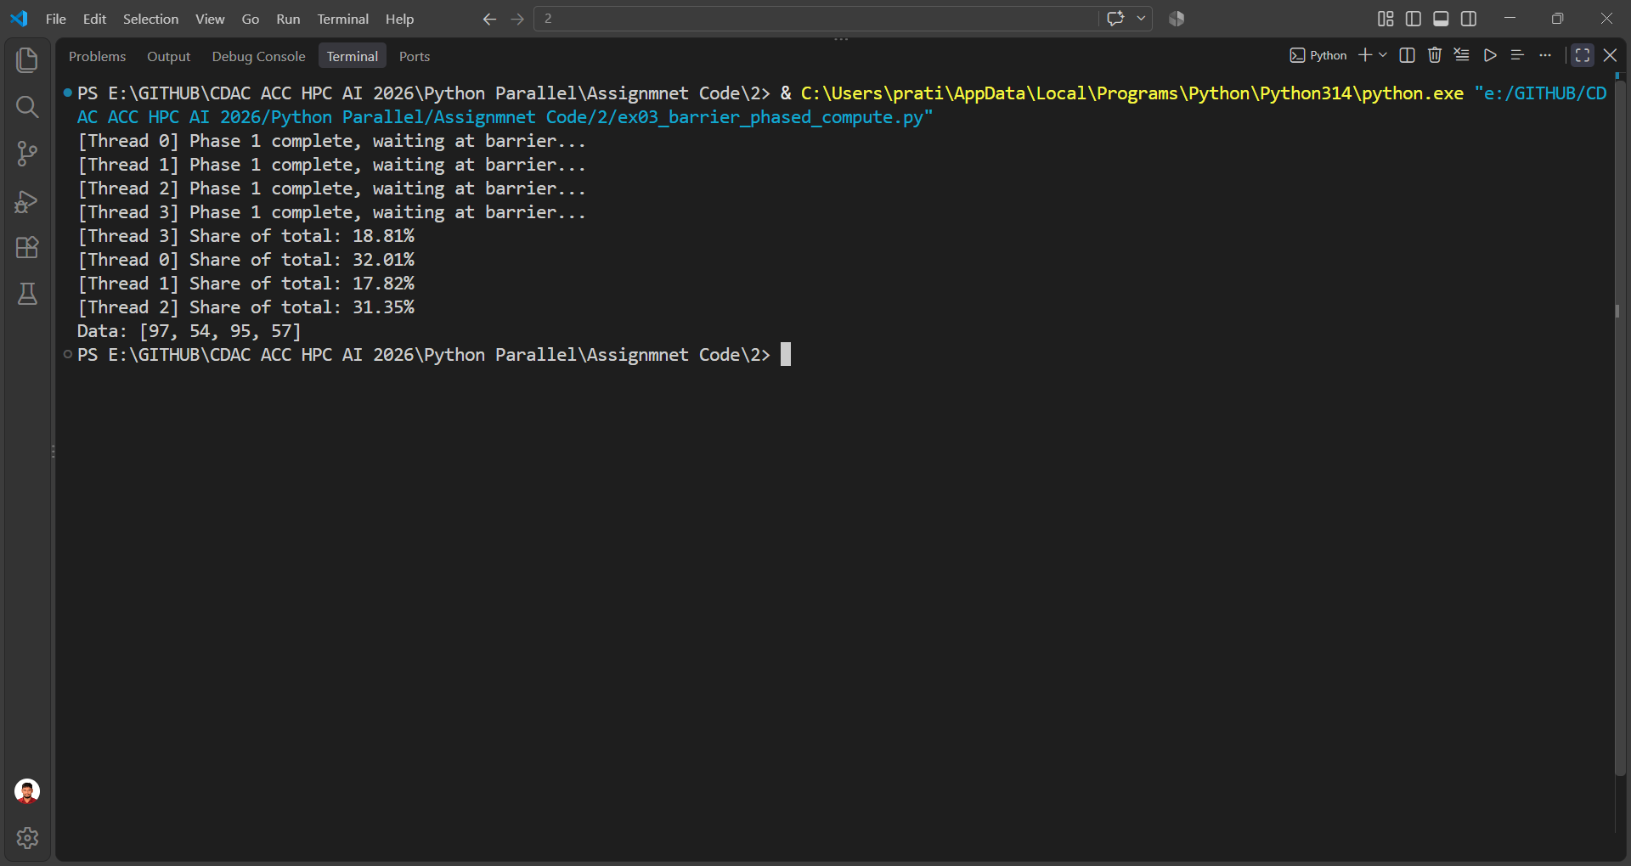

Exercise 4 — Queue & Pipe Process Pipeline
The producer sends 15 numbers to a Queue, the filter keeps even numbers, and the writer receives them through a Pipe.
Code:
import multiprocessing
import random

# Producer process
def producer(queue):
for _ in range(15):
number = random.randint(1, 100)

queue.put(number)

print("[Producer] Sent:", number)

# Sentinel value
queue.put(None)

# Filter process
def filter_numbers(queue, pipe_connection):
while True:
number = queue.get()

# Stop when producer is finished
if number is None:
pipe_connection.send(None)
break

# Keep only even numbers
if number % 2 == 0:
pipe_connection.send(number)
print("[Filter] Sent even number:", number)

pipe_connection.close()

# Writer process
def writer(pipe_connection):
values = []

while True:
number = pipe_connection.recv()

# Stop when filter is finished
if number is None:
break

values.append(number)

print("[Writer] Accepted:", number)

print("[Writer] Final values:", values)

pipe_connection.close()

if __name__ == "__main__":

# Create Queue
queue = multiprocessing.Queue()

# Create Pipe
filter_connection, writer_connection = multiprocessing.Pipe()

# Create Producer process
producer_process = multiprocessing.Process(
target=producer,
args=(queue,)
)

# Create Filter process
filter_process = multiprocessing.Process(
target=filter_numbers,
args=(queue, filter_connection)
)

# Create Writer process
writer_process = multiprocessing.Process(
target=writer,
args=(writer_connection,)
)

# Start all processes
producer_process.start()
filter_process.start()
writer_process.start()

# Wait for all processes
producer_process.join()
filter_process.join()
writer_process.join()

print("Pipeline finished.")

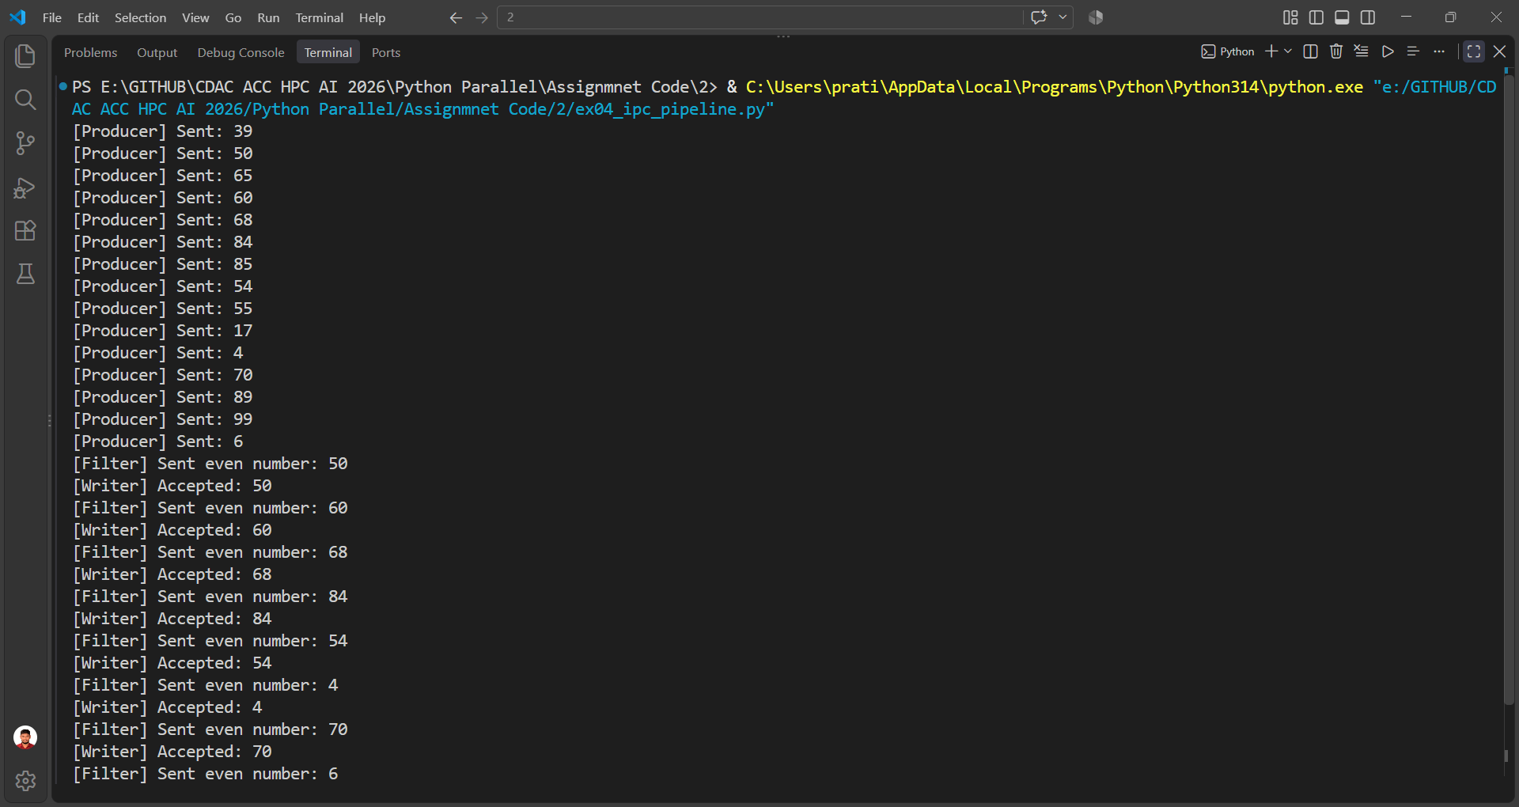

Exercise 5 — Async Pool with Callbacks
Eight tasks are submitted with apply_async(). The callback collects results while the main process prints a ticker.
Code:
import multiprocessing
import time
completed_records = []
def process_record(record_id, data_chunk):
time.sleep(0.5)
return {
"record_id": record_id,
"processed_elements": len(data_chunk),
"checksum": sum(data_chunk)
}
def collect_result(result):
completed_records.append(result)
print("Completed:", result)
def log_error(error):
print("Error:", error)
if __name__ == "__main__":
pool = multiprocessing.Pool()
for i in range(8):
chunk = list(range(i + 1, i + 6))
pool.apply_async(
process_record,
args=(i, chunk),
callback=collect_result,
error_callback=log_error
)
# Visual ticker: main process is still running.
while len(completed_records) < 8:
print(".", end="", flush=True)
time.sleep(0.1)
print()
pool.close()
pool.join()
print("\nAll records processed.")
print("Summary:")
for result in completed_records:
print(result)

